Customize a Segments Shape

Customize a Segments Shape as below:
Note: the unit is Metric. The blue line is the sketch of rebar shape. The red rectangle indicates each bend. The center x and y axis is a coordinate system, we just concern its direction, and its origin can locate anywhere. Other black lines are dimensions.
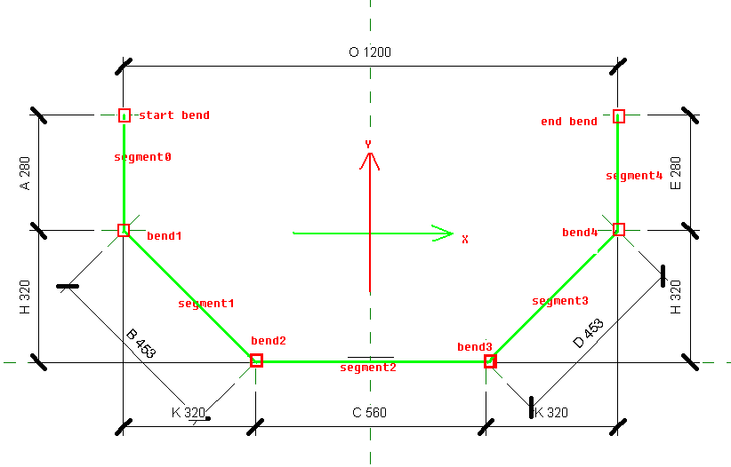

Step by step to define above shape:
1. Input rebar shape name “MyShape”. Then click the radio button “By Segments” and input segment number 5. Then click button “Create Rebar Shape”.
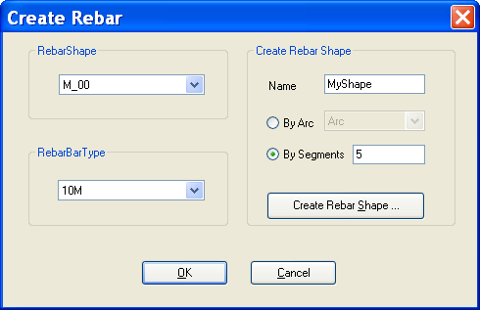

2. After the first step, a form “Create RebarShape” will be presented as below.
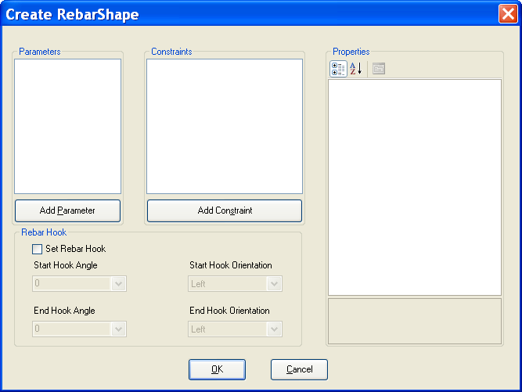

3. Click button “Add Parameter”. Picture as below:
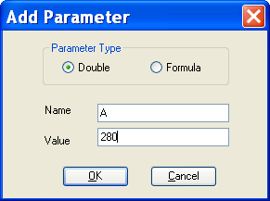

Click OK button, the parameter will be added to the previous form’s parameter’s list.
Picture as below: The property grid will show the selected parameter and also can change the parameter value.
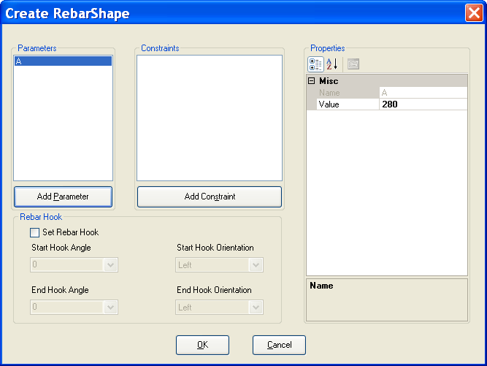

4. Repeat step 3, add other six double parameters, picture as below:
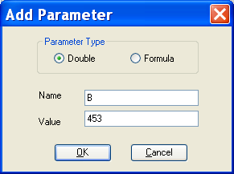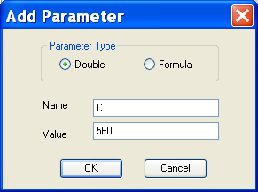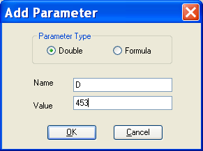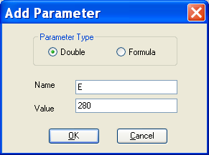
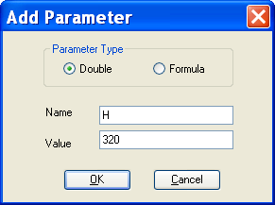

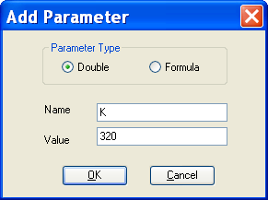

5. Add O as formula dimension: 2*K+C.
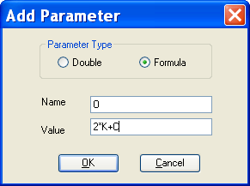

6. After we add all the parameters, the form looks like:
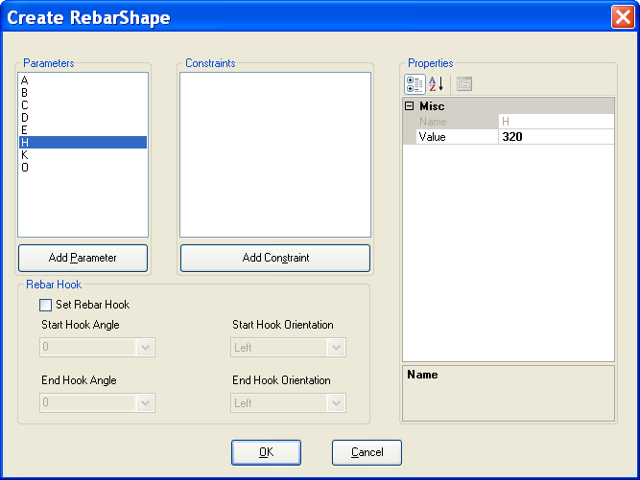

7. Add Constraints to constrain the segments and bends.
Click “Add Constraint” will present a form to select a constraint type, after click OK button, the constraint will be add to the constraint’s list, and after this, you must initialize the constraint in the property grid. The form as below:
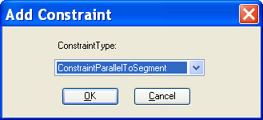

A. Constrain segments length:
1). Add ConstraintParallelToSegment to constrain segments0’s length.
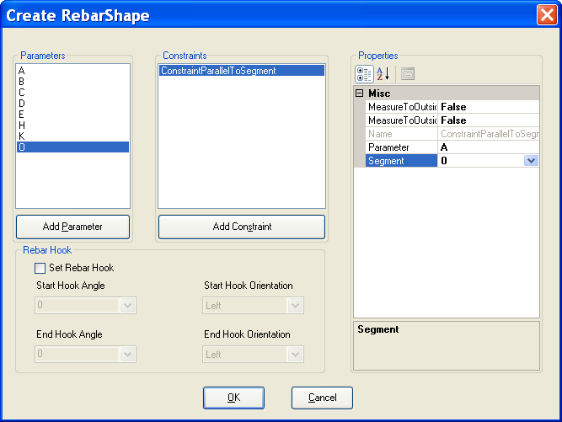

2). Add ConstraintParallelToSegment to constrain segment1’s length.
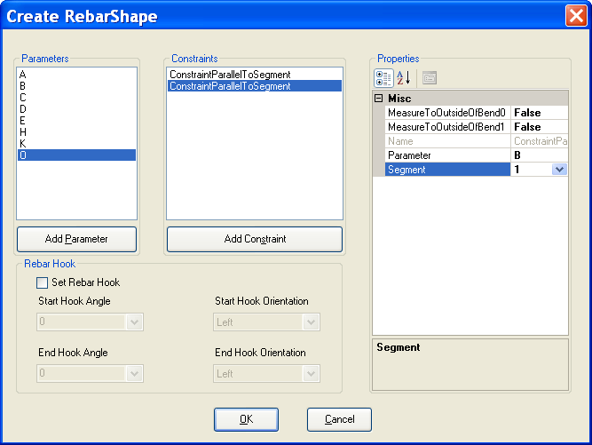

3). Add ConstraintParallelToSegment to constrain segment2’s length.
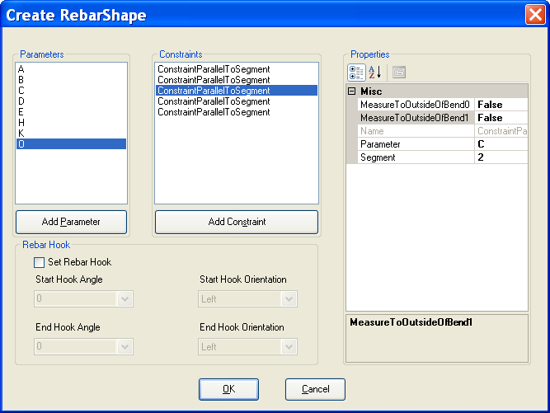

4). Add ConstraintParallelToSegment to constrain segment3’s length.
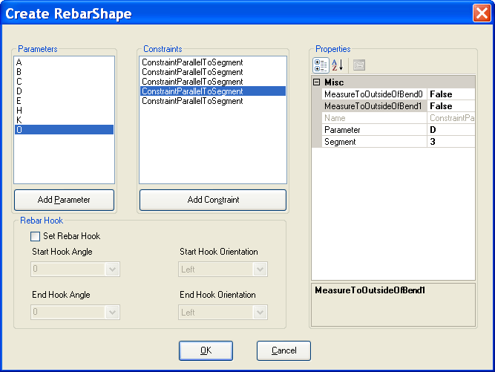
5). Add ConstraintParallelToSegment to constrain segment4’s length.
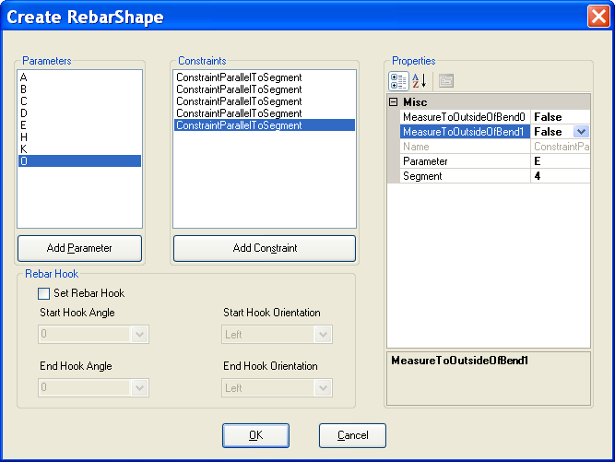

B. Constrain segment direction:
1) Add SegSegmentFixedDirection to constrain segment0’s direction.
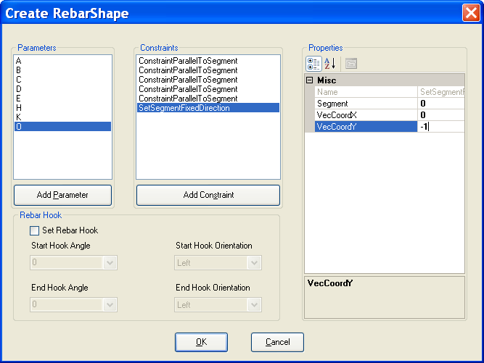
2) Add SegSegmentFixedDirection to constrain segment2’s direction.
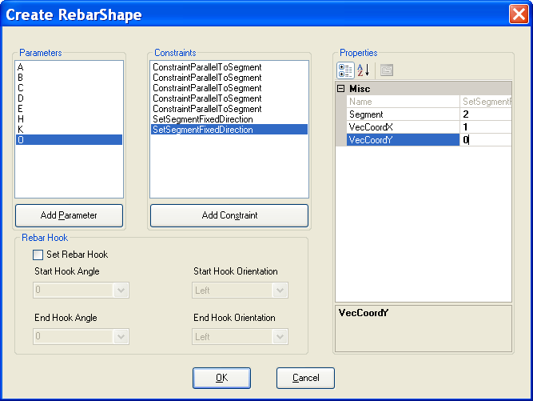

3) Add SegSegmentFixedDirection to constrain segment4’s direction.
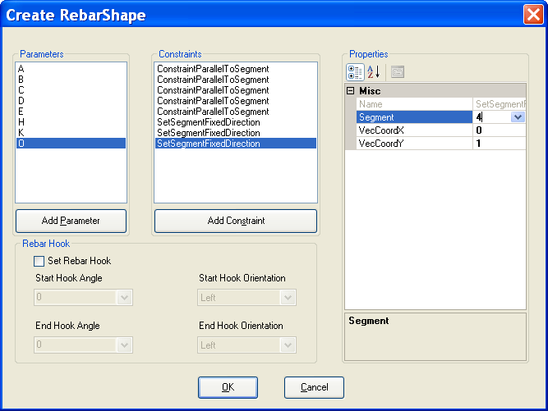

4) Add ConstraintToSegment to constrain segment1’s length in opposite of Y axis.
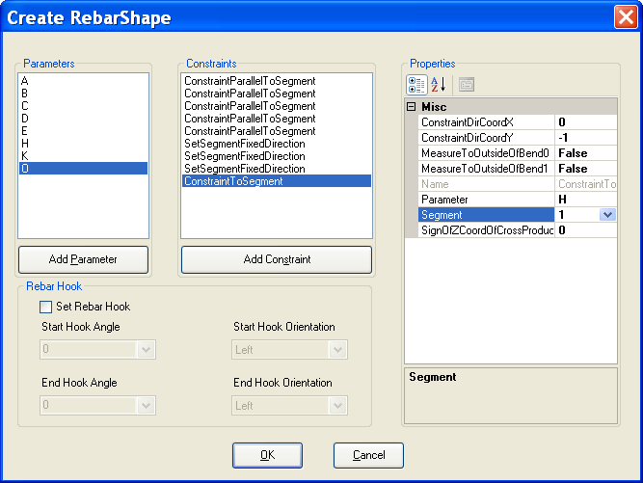

5) Add ConstraintToSegment to constrain segment1’s length in X axis.
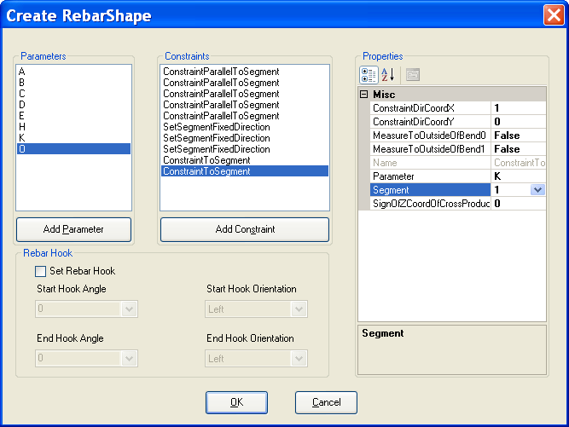

6) Add ConstraintToSegment to constrain segment3’s length in X axis.
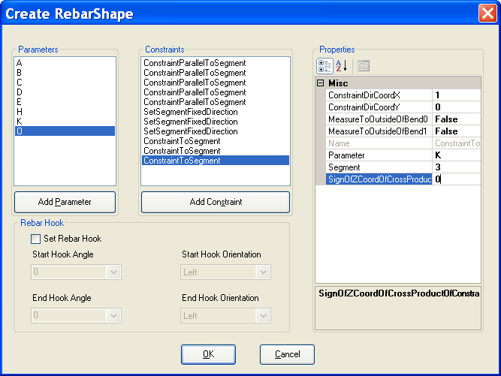

7) Add ConstraintToSegment to constrain segment3’s length in Y axis.
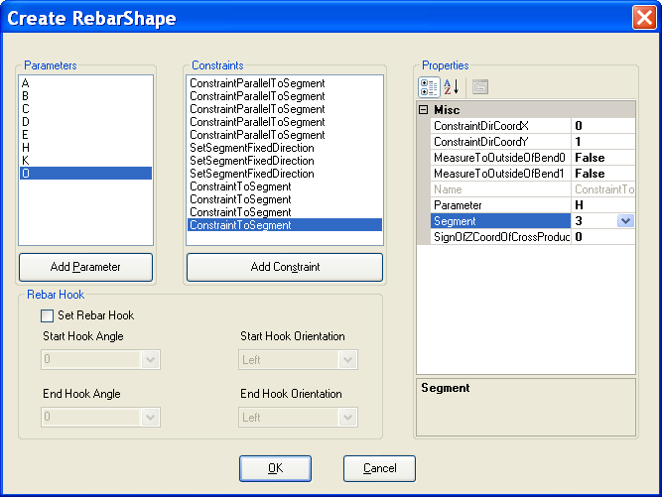

C. Constrain bends between two segments:
1) Add ConstraintBendDefaultRadius to constrain bend1’s radius.
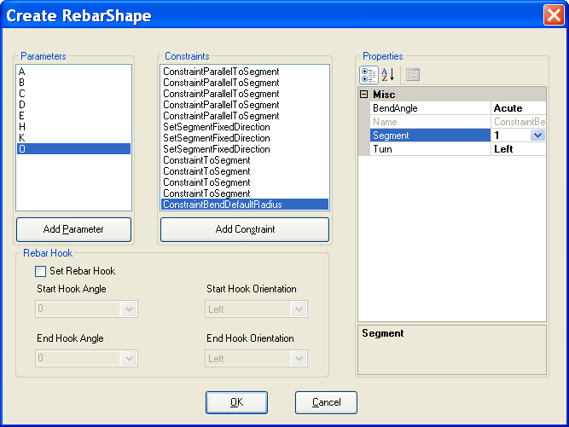

2) Add ConstraintBendDefaultRadius to constrain bend2’s radius.
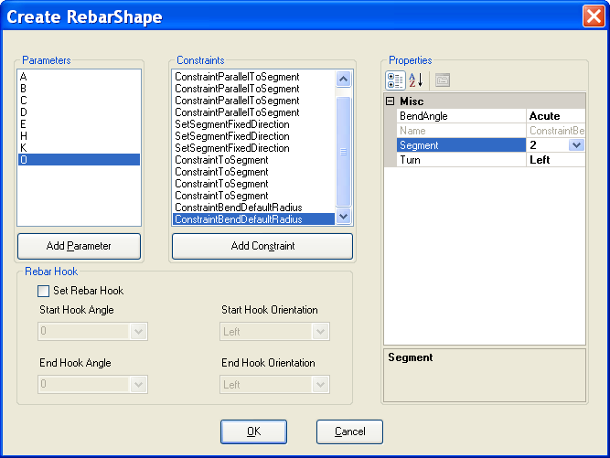
3) Add ConstraintBendDefaultRadius to constrain bend3’s radius.
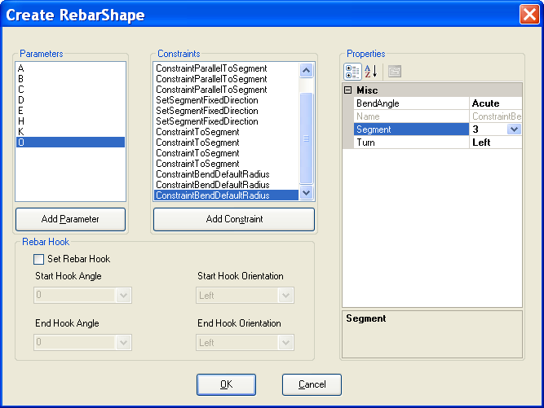

4) Add ConstraintBendDefaultRadius to constrain bend4’s radius.
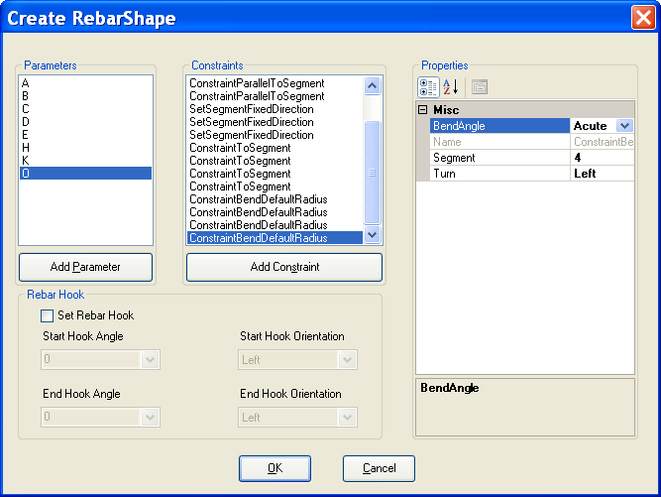

C. Add ListeningDimensionBendToBend between start bend and end bend in X axis direction:
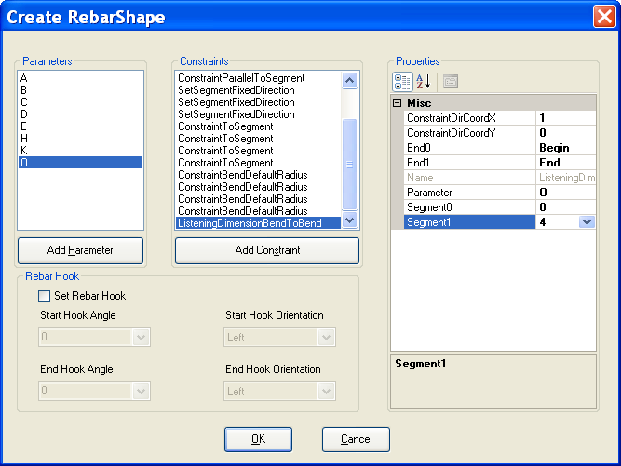

D. You also can set Hook for start bend and end bend. Just make checkbox status to check and set hook angle and hook orientation.

After all above steps, click OK button in “Create RebarShape”. It will return to “Create Rebar” form and the newly defined rebar shape will be selected. Just click OK button to create a Rebar with this rebar shape.
